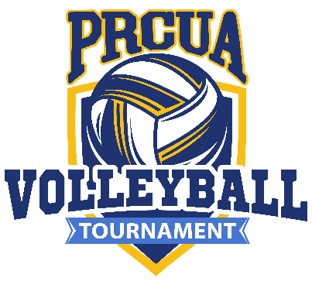
5th PRCUA NATIONAL VOLLEYBALL TOURNAMENT
October 14-15, 2022 | Shelby Twp., MI
Hosted by PRCUA Society 261

ENTRY FORM

Team Name _____________________________________________________________ City _________________ ____ State _

Mark the circle indicating in which division your team will play: MEN (6 vs. 6) WOMEN (6 vs. 6) CO-ED (6 vs. 6)

Each player may only sign one roster and must submit a Waiver of Liability form for 2022. This tournament is for PRCUA members only. Non-members should contact the PRCUA at 773-782-2642. Players must agree to abide by the PRCUA rules and regulations of good sportsmanship and fair play on and off the courts. MHSAA Volleyball Rules apply, no libero.
# | PRINT PLAYER’S FULL NAME | ADDRESS - NUMBER, STREET, CITY, ZIP | PHONE # | EMAIL ADDRESS | SOCIETY | ROSTER
1
2
3
4
5
6
7
8
9
10
11
12

Entry fee is $50.00 per team and must be paid prior to the tournament. Fees are non-refundable. Make checks payable to PRCUA Volleyball or use the online payment option at www.prcua.org/payonline, indicating you are paying for: “Volleyball Tournament - Team Name.” Send application and fee to: PRCUA Fraternal Department, 984 N. Milwaukee Ave.,
Chicago, IL 60642-4101 or Fraternal-Department@prcua.org.

As manager or coach of the above team, I am responsible for the conduct of all of my team players and for the correctness of all of the above information. I understand that if any player's information has been falsified for any reason, all games in which that player(s) participated will be forfeited.

Captain/Coach Address City State Phone

Entries must be received no later than Friday, September 30, 2022

