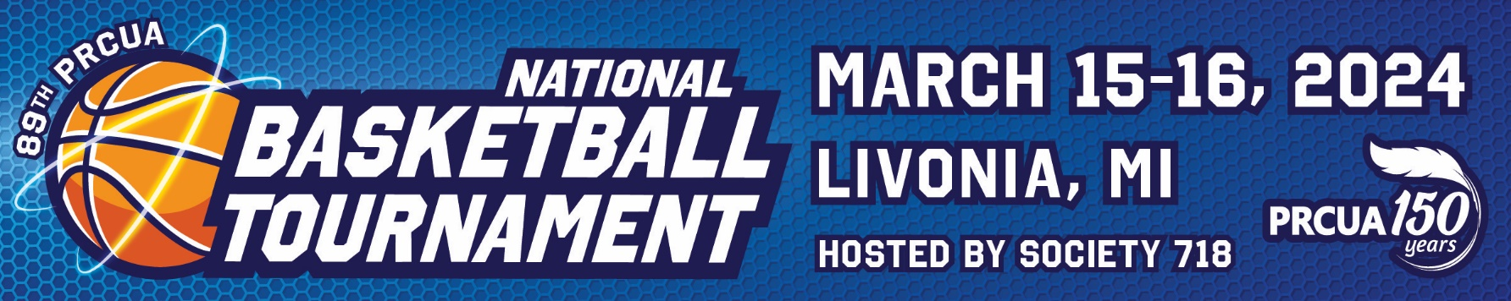
TOURNAMENT INFORMATION
Game Times
• Opening ceremony on March 16 at 9 am
• Games begin after opening ceremony
• More details provided once the number of teams is determined
Divisions
• Women’s 3x3
• Men’s Open
• Men’s Over 50 (3x3)

ENTRIES
Entry forms, waivers of liability and payments can
be submitted electronically or via USPS
Deadline: Friday, February 16

LODGING
Embassy Suites by Hilton
19525 Victor Parkway
Livonia, MI 48152
(734) 462-6000
• PRCUA rate $159 Double with pullout sleeper sofa; $139 King Suite with pullout sleeper sofa. Applicable taxes apply.
• Group name: PRCU
• Reservations must be made by February 24
• Includes Manager’s Special on Sunday: full breakfast and two complimentary drinks at the bar

HOSPITALITY
Monaghan Knights of Columbus Hall
19801 Farmington Rd.
Livonia, MI 48125
Friday, March 15
• Hospitality hosted from 6-10 pm
• Includes light food and beverages

SPORTS VENUE
Stevenson High School
33500 6 Mile Rd.
Livonia, MI 48015

AWARDS CEREMONY
Monaghan Knights of Columbus Hall
19801 Farmington Rd., Livonia
Saturday, March 16
Doors open at 6 pm

CELEBRATION OF MASS
St. Colette Parish
17600 Newburgh Rd., Livonia
Mass Times: 4 pm Saturday; 8 am, 10 am 12 noon Sunday

TOURNAMENT HOST
PRCUA Society #718
Robert Hojnacki, Chairperson

