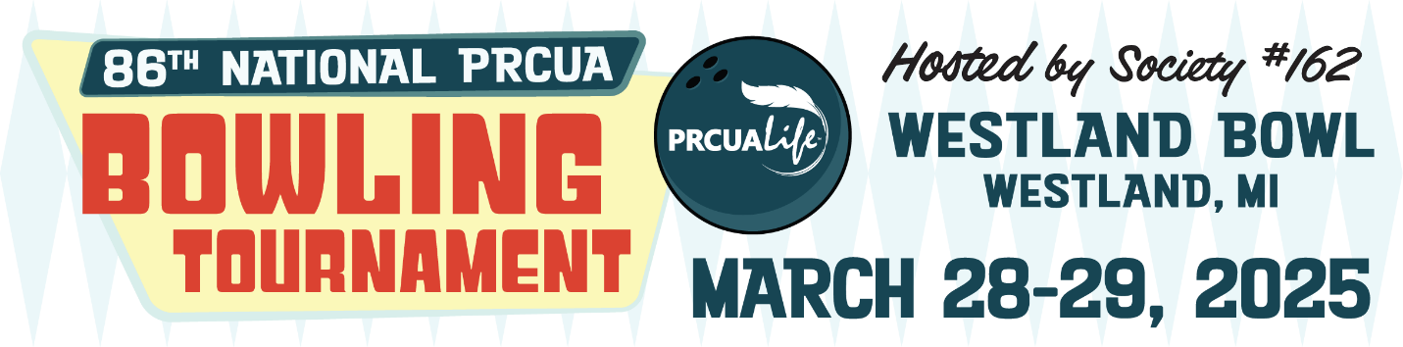

Dear PRCUA Member,

PRCUA Society #162 is looking forward to hosting the 86th Annual National Bowling Tournament in Westland, Michigan on March 28th and 29th.

The tournament will be held at Westland Bowl:

5940 N. Wayne Rd., Westland, MI 48185

(734) 722-7570

[www.westlandbowl.com](http://www.westlandbowl.com)

Hotel accommodations have been reserved at Comfort Suites:

18950 N. Northline Rd., Southgate, MI 48195

(734) 287-9200

* PRCUA rate: $119 plus taxes per night   
  (1 King or 2 Double)
* Ask for PRCUA Bowling rate when booking
* Group rate reservation deadline is March 7th
* Includes breakfast buffet daily

Hospitality will be on Thursday and Friday at the PRCU #162 Hall:

1430 Oak St., Wyandotte, MI 48192

* Hospitality hosted from 6:30-9:00 pm
* Includes light food/snacks and complimentary draft beer and wine
* The 162 lounge will open at 3:00 pm on Friday

Local Mass schedule:

Our Lady of the Scapular Church

976 Pope John Paul II Ave., Wyandotte, MI 48192

5:00 pm Saturday; 9:00 am (Polish), 11:00 am (English) Sunday

The tournament schedule is as follows:

Friday, March 28th – Doubles/singles at 11:00 am

Saturday, March 29th

11:00 am – Opening ceremony

11:30 am (approx.) – Team event

Send in your completed entry form (along with the appropriate entry fees) by the deadline. Please be sure to fill in all information on your entry form, including average information. The deadline for submitting entries is **Friday, February 28th**.

A secured room for overnight bowling ball storage will be available. There is a tournament office located at the bowling alley; details will be provided at the facility upon arrival.

The host society will offer jackpots and other raffles as follows:

* 50/50 raffle each day
* Jackpots for men and women, Actual, Handicap

The awards ceremony will be held on Saturday at the PRCU 162 Hall (address listed above) and will include a Polish buffet dinner (complimentary for all bowlers; guests pay $20).

* Doors open at 6:00 pm, dinner served at 6:30 pm
* Awards ceremony immediately following dinner

Society #162 will be preparing a commemorative ad book for the tournament as a means of raising funds for this event. See attached ad packet for information regarding the booklet; we hope that you or your society can participate.

Anyone who wishes to play in the tournament, but is not yet a member, must become a member BEFORE February 28th. Please contact [sales@prcua.org](mailto:sales@prcua.org), (773) 782-2755 to purchase an insurance certificate or annuity.

Also, to clarify member status, a member of the PRCUA in good standing is defined as someone who willingly pays on a life insurance certificate, owns a fully paid-up life insurance certificate or has an active annuity certificate.

A member **not** in good standing is defined as someone who has willingly stopped paying on a certificate and took the option to use the cash value to keep the same amount of death benefit but for a certain number of years.  A member not in good standing includes certificates of insurance being identified as suspended or those being on extended insurance. A member not in good standing is not eligible to vote at a PRCUA convention, participate in participate in sport tournaments or one of PRCUA’s subsidized programs, such as the dance and gymnastics groups or Polish language schools.

A social member of a society (one who pays membership to only the society) who does not own a life insurance certificate or annuity is not considered a member in good standing of the PRCUA and cannot take advantage of member benefits.

Please contact the PRCUA Fraternal Department at (773) 782-2601 or [fraternal-department@prcua.org](mailto:fraternal-department@prcua.org) if you have any questions about the tournament, Valerie Brumm (248) 622-8949 with bowling-related questions (such as averages), or Stan Pasko (313) 815-5230.

Valerie Brumm

PRCUA Bowling Director

***Additional information available in the Naród Polski and online at*** [***www.PRCUA.org/bowling***](www.PRCUA.org/bowling)