# GOLF COURSE

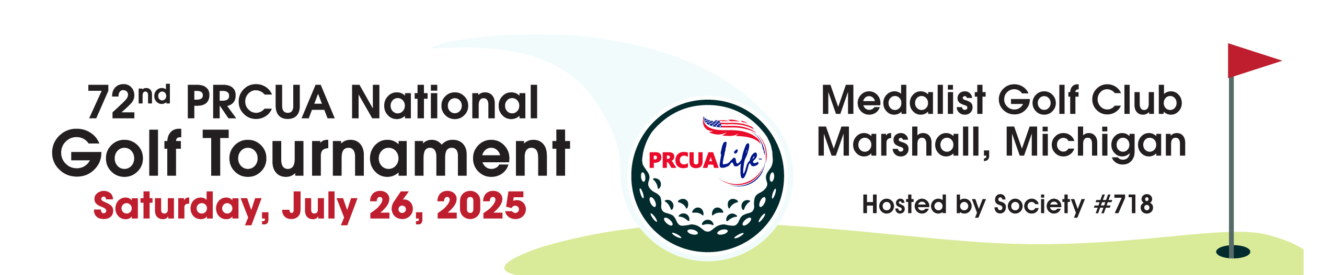

#### The Medalist Golf Course

15701 N-Drive North

Marshall, MI 49068

www.themedalist.com

(269) 789-4653

# LODGING

**Quality Inn**

11081 E. Michigan Ave., Battle Creek, MI

$148 per night incl. tax & fees

**Fire Keepers Casino and Hotel**

11177 E. Michigan Ave., Battle Creek, MI

$258 per night incl. tax & fees

These are discounted rates. For the discount all rooms MUST be booked through Lowell Weaver at The Medalist Golf Club: (269) 789-4653

Discounted rooms are limited to 25 rooms at Firekeepers and 40 rooms at The Quality Inn.

Book early to ensure availability.

**WELCOME GATHERING**

Friday, July 25

**Location and Time**

**TBD**

Includes complimentary snacks and beverages

## DINNER AND AWARDS CEREMONY

Immediately following the afternoon round.

Free for all golfers; $30 per person for additional guests and non-golfers. Cash bar.

## GOLF TOURNAMENT

* Shotgun Start: 8:30 AM and 1:30 PM

* Four-Person Scramble



Lunch provided for all golfers

## TOURNAMENT ENTRY

Entry forms are available with this notice or online at prcua.org/sports. Registration fee (non-refundable) is

$100 for PRCUA members. **Entries must be completed and submitted by June 20, 2025. No entries will be accepted after the deadline.**

## TOURNAMENT SCRAMBLE RULES

On every hole, each team member will hit a tee shot. The team determines the best shot and then all team members hit from that location. This is repeated until the ball is holed out. A team score is recorded and the team moves to the next hole.

**FOURSOME CATEGORIES**

Men – 4 Men under 70 years of age

Women – 4 Women under 70 years of age

Mixed – 2 Men & 2 Women under 70 years of age.

Senior – 70 years of age and over. This group can be all men, all women or mixed.

# CONTESTS

### PAR 3 CLOSEST TO THE PIN

### There will be 2 par 3 holes designated for the closest to the pin contest. There will be a men’s, women’s and a senior category for men & women over 70. Men will use the white tee, women & seniors use the forward red tees. The tee shot on the green, closest to the hole, wins.

### LONGEST DRIVE

The winner is the player who hits their tee shot the farthest while keeping the ball in the fairway. This contest will have the same 3 categories as the closest to the pin contest.

## TOURNAMENT HOSTS

PRCUA Society 718

Dan Gdowski, President

Jeff Gliwa, Chairperson