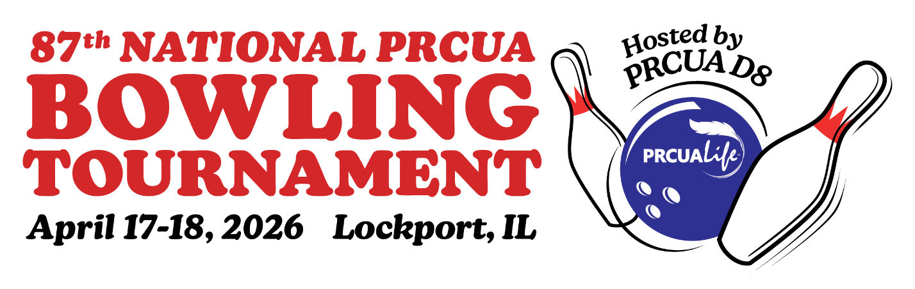

Dear Friends of the Polish Roman Catholic Union of America,

PRCUA District 8, is hosting the 87th PRCUA National Bowling Tournament on Friday and Saturday, April 17 and 18, 2026. This event will be held at Strike N Spare II in Lockport, IL where we hope to attract over 200 bowlers competing in Singles, Doubles and Team events, followed by several fraternal and social activities in the area.

As part of the welcome packet, each participant will receive an ad book when they arrive. What a great way to advertise your business, or send good luck wishes to the bowlers while they are in town for the tournament!

Please consider supporting PRCUA District 8 and the Bowling Tournament by placing an ad in our book. The deadline to submit your ad is March 20, 2026.

Please see ad form on reverse side for size and price options.

Thank you again for your support to our Society!

Sincerely,

Krystyna Lech
President, District 8


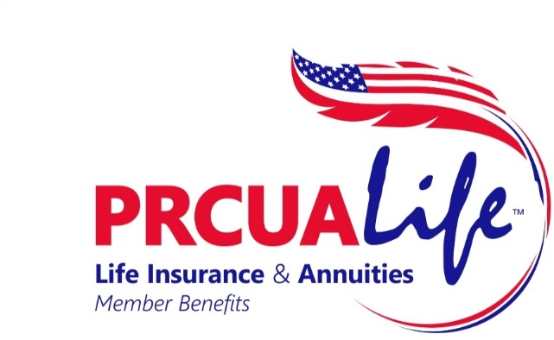

PRCUA 87th National Bowling Tournament ad book

Cover page ad – $150
Inside Front, Inside Back or Outside Back Cover (8 ½ x 5)

Full page ad (8 ½ x 5) – $100

Half page ad (4 ½ x 5) – $50

Quarter page ad (2 ½ x 5) – $35

Patron/one line sponsor – $10

Please send your advertisement and check to:

Danielle Kroplewski

13100 Ballycastle Ct.
Lemont, IL 60439

Make check payable to PRCUA District 8

Please email the ad/artwork to daniellekroplewski@gmail.com

DEADLINE FOR ADS: March 20, 2026

Thank you for supporting the Polish Roman Catholic Union of America.

Krystyna Lech
President, District 8

